Parallel Computing

==================

** P2P Networks **
NUMA point-to-point architecture where each processor has two connections to other
processors, and one connection to memory. The connections for four processors is shown below
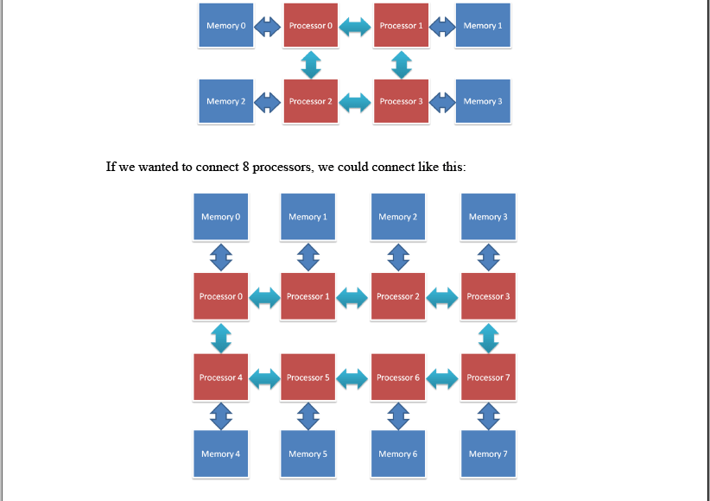

When we have only four processors, the maximum number of jumps (or hops) for a processor to get data from a remote memory is 6 hops. E.g., from processor 0 to the memory of processor 3. When we have 8 processors, the maximum number of hops is 10 hops. E.g., from processor 0 to the memory of processor 7. One way to reduce the number of hops (which reduces communication latency) is to increase the number of connections on each processor. For example, if each processor has three connections, a four processor layout could look like this
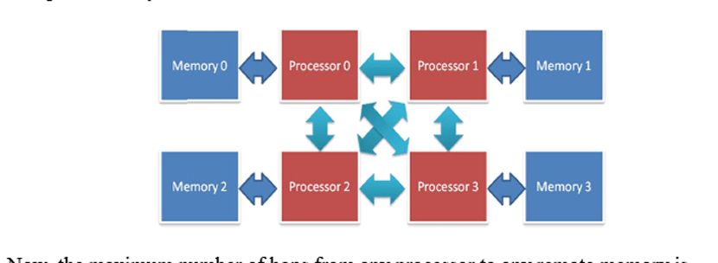
Now, the maximum number of hops from any processor to any remote memory is reduced to 4. The downside of this approach is that the processor chip becomes more complicated, because it needs more connections for the point-to-point network. However, large IBM supercomputers have processors with up to six connections, so three connections is not a problem.

السؤال:
drawing that connects 8 processors, with each processor supporting up to three connections
(a processor does not have to use all connections, and any processor can connect to any other
processor).
a. for a correct drawing
b. for reducing the maximum number of hops to 8
c. for reducing the maximum number of hops to 6

**Cache Coherency and False Sharing :
Cache coherency is needed to ensure that processors do not see different values for the same variable. More concretely,
it ensures that processors do not see different values for the same memory address, because hardware does not know the names of the variables in the program code. The main idea of cache coherency is three rules. Only one processor can have write permission to to a memory address at any time. No processor can have read or write permission to a memory address if any other processor has write permission for that memory address. Many processors can have read permission for a memory address at the same time.
The simplest cache coherency protocol is ESI. Although cache coherency is important for making sure a program executes correctly, it leads to false sharing, which can cause performance problems . In order to remove false sharing, we have to move variables in memory so that they fit in different cache lines. For example, in the situation shown below, we need to move the green variable by at least 2 boxes (move it to the right), so that it goes into a cache line with a different memory address

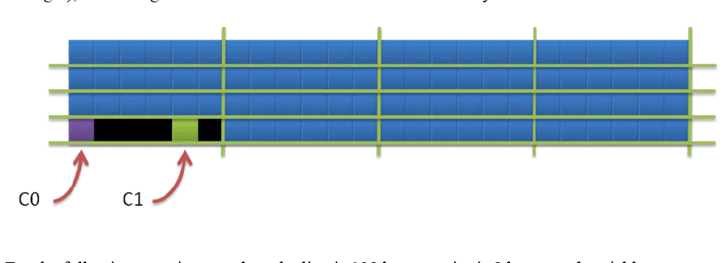

For the following questions, each cache line is 128 bytes, an int is 8 bytes, and variable ‘x’ is an int, and variable ‘y’ is an int.

Variable x is at memory address 0, and variable y is at memory address 8-1-
(they are next to each other). What is the minimum number of bytes by which we have to move y so that it is in a different cache line?

-2- Variable x is at memory address 24, and variable y is at memory address 88
What is the minimum number of bytes by which we have to move y so that it is in a different cache line?

-3- Variable x is at memory address 120, and variable y is at memory address 128. What is the minimum number of bytes by which we have to move y so that it is in a different cache line?

