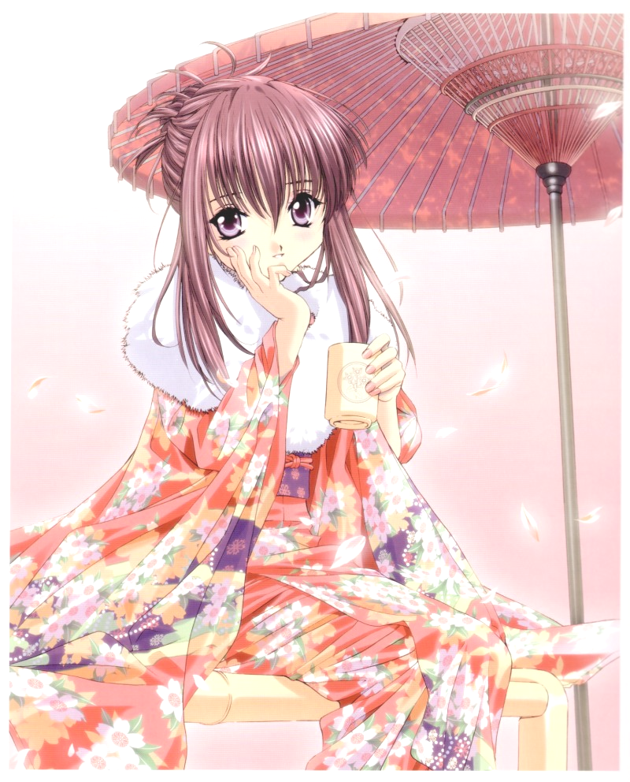
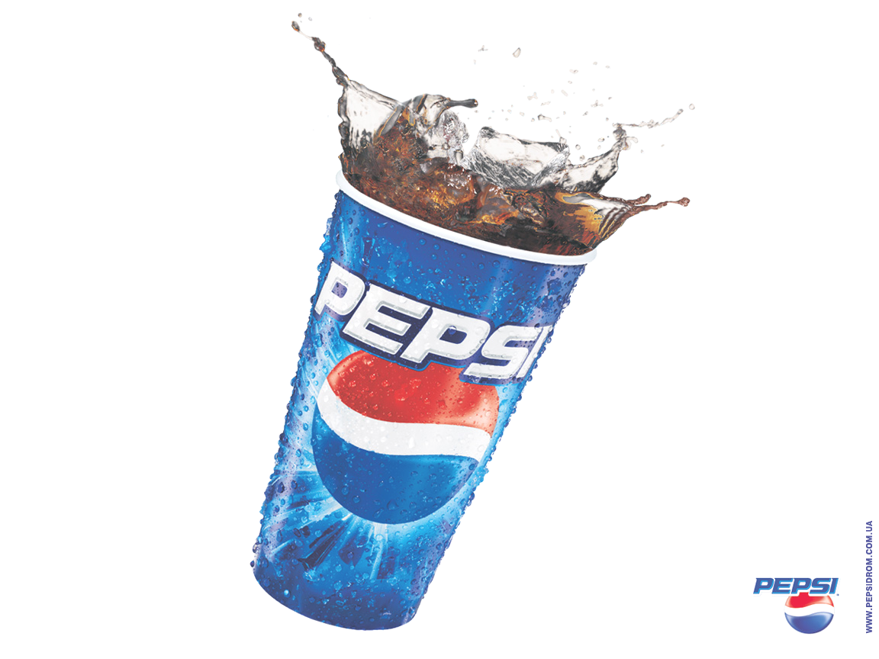
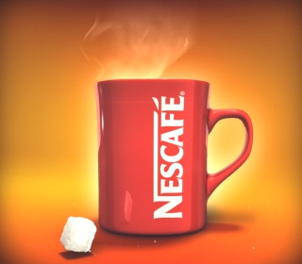
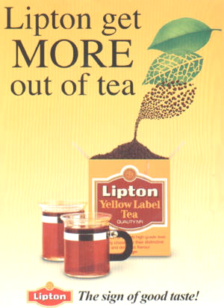
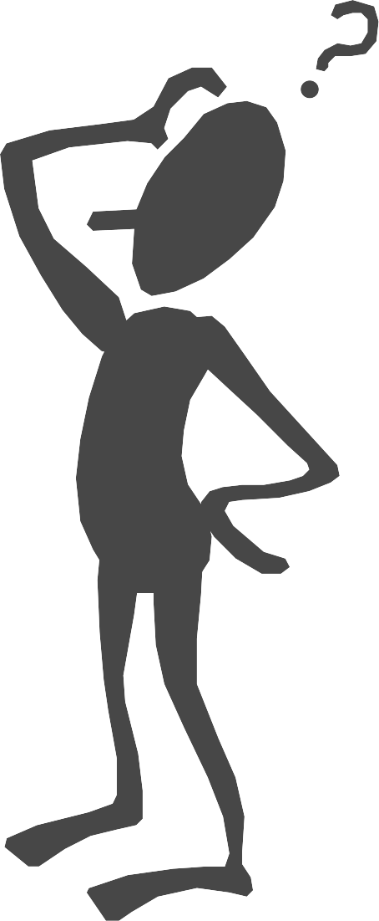
What is her favourite drink ?
What does our lesson talk about ?
It talks about ……………………………………………………………
What are these beverages above ? Can you name them ?
These are ……………….. , ……………………….. , …………………

Most people like to drink beverages. Why ?
Because they are refreshing and improve their performance.

I think the most popular drink in the world is pepsi..What about you? What would you rather drink ?

....................................................................................................................................................................................................................................

If you ask me about my choice, I will choose tea. I like to use tea bags. I don't like to use loose tea. They are easy to use.

Can you tell where do coffee and tea come from?

Yes, coffe comes from these countries : …………………………………… and tea ………………………………………………………………………

Very good. Ok. What are they made of leaves
or beans ?
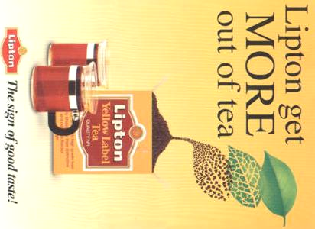
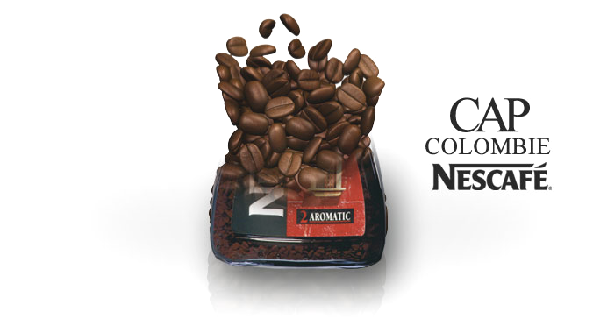

Coffee ……………………………………………….. and tea ……….........
………………………………………………………………………………..

You and your friend are in the café and you are talking about your favorite drinks.
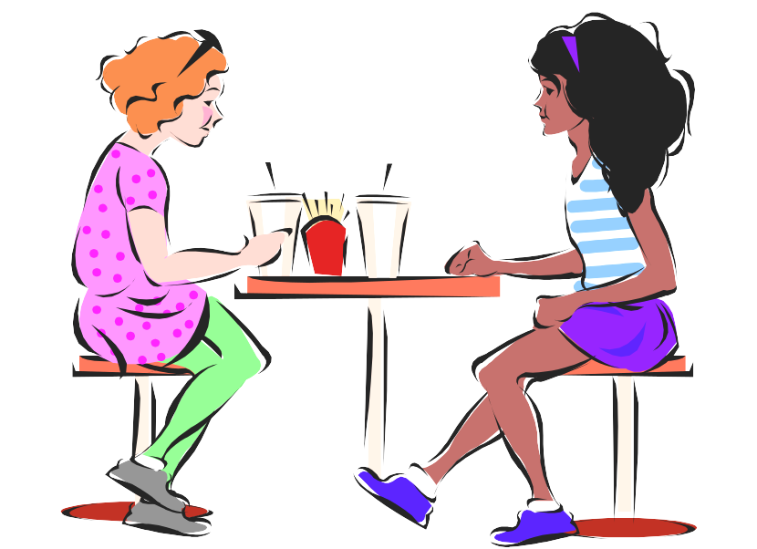
……………………………………………………………………
……………………………………………………………………
……………………………………………………………………
………………………………………………………………
……………………………………………………………………
……………………………………………………………………

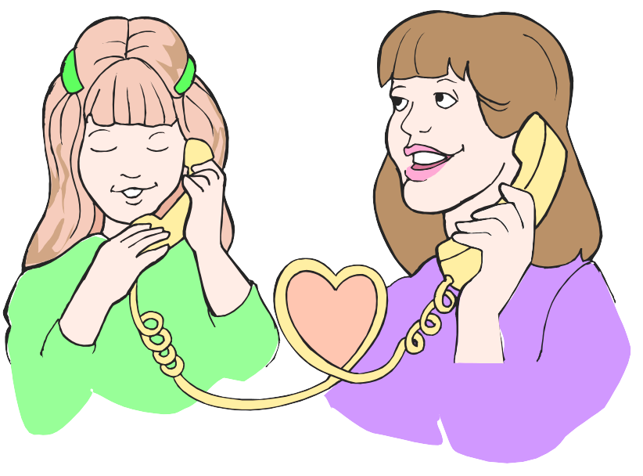
……………………………………………………………………
……………………………………………………………………
……………………………………………………………………
………………………………………………………………
……………………………………………………………………
……………………………………………………………………
You are talking to your mother about how tea is made. Use these words:( boil – tea pot – sugar – water-- put – stir – cup )

Tr. Samia Al-Raddadi-1426Ah

