1. Read the passage and answer the questions:
2nd quiz ~ Unit: 2+3 | class: 2/2a
Pupil’s name:
.......................................................
Mary found an earring. Whose earring is it?
Is it Aunt June's earring? No. Aunt June's
earrings are silver. This earring is gold.
Is it Mommy’s earring? No. Mommy’s earrings are square. This
earring is round.
Is it Ms. Santos’ earring? No. Ms. Santos’ earrings have feathers.

This earring has beads.
Is it Aunt Lucy’s earring? No. Aunt Lucy’s earrings are large. This
earring is small.
Whose earring can it be?
“Silly,” said Sara. “It’s your earring, Mary! Put it back in and let’s go
play.”
So they did.

a. Who found the earring?
..........................................................................................................................
b. What colour are Aunt June’s earrings?
..........................................................................................................................
c. Whose earring is it?
..........................................................................................................................

d. Circle the correct word to complete each sentence:
- The earring she found is ( silver – black – gold ).
- The earring she found is ( square – round – triangle )

2. Choose the correct completion:
1. …………………… are caused of fires.
* scalds * burns * suffocation
2. …………………. is caused when eating or drinking something bad or overdosing medicine.
* electrical * out let * poisoning
3. ………………….. is the land at the edge of the sea
* peninsula * coast * island

3. Match the following:
(A) (B)
1. against ◻ the ability to see
2. permanently ◻ opposite of easy
3. sight ◻ a preposition
4. difficult ◻ for a long time
◻ healthy because of exercise.

4. Choose the correct word:
( sweet – continent – far )
a. Japan is ........................... from Saudi Arabia.
b. Australia is a ..................................................

5. Write the correct word under each picture:
( silk – stars – ink )

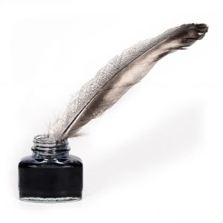

............................... ..............................
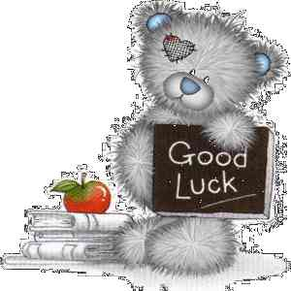
Tr.Samia Al-Raddadi

_________
10

