Unit: One

English Literature

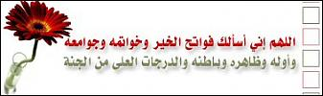

Word | معناها | Meaning
act (n) | يتصرف /يمثل | behave
actor (n) | مـمـثـل | a person who acts in a play
allowance (n) | مصروف | money given regularly to a person
agent (n) | وكيل | a person who manage the business of another
attempt (v) | يحاول | try
as if (conj) | كأن | as it would be if
author (n) | مؤلف | writer
autobiography(n) | سيرة ذاتية | true story about the author. ِA
biography (n) | سيرة | true story about the life of a real person.
bring up (v) | يربي | take care of a child
capture (v) | يقبض على/يحتل | catch
career (n) | مهـــنة | job = work
character (n) | شخصية | the people in a novel or a play
childhood (n) | مرحلة الطفولة | the time when you are a child.
convict (n) | مذنب | guilty
effort (n) | مجــــهود | hard work
escape (v) | يهرب | run away
expectations(n) | آمـــــال | things you hope will happen
fiction (n) | خيال/قصة | imagined
fictional (adj) | خيالي | something imagined
firm (n) | شركة | company
fortune (n) | ثروة | wealth , money
gentleman (n) | سيد | a man who acts well
insurance (n) | تأمـــــين | an agreement to pay money in case of illness, death or accident
kind (adj) | عـطــوف | helpful
kindness (n) | عطف | being kind
literature (n) | أدب | the art of writing
lonely (adj) | وحيــــد | alone or without friends
manhood (n) | مرحلة الرجولة | the time of being man
novel (n) | رواية | a long story that people read.
orphan (n) | يتيم | having no parents
part owner (n) | شريك | a person who shares the ownership of something.
play (n) | لعب / مسرحية | a piece of writing for the theatre.
poem (n) | قـصـيــدة | a piece of writing
poet (n) | شاعـــر | a person who writes poems.
poetry (n) | شـــعــر | poems in general
prison (n) | سـجـن | jail
prisoner (n) | سجين | a person kept in prison as a punishment
sentence (v) | يحكم على | say the punishment in the court.
stage (n) | منصة / مرحــلة | a place where actors stand to perform a play.
strict (adj) | صـــارم | hard
Support | يدعـم | help
theatre (n) | مـسـرح | where plays are performed
trial (n) | قضية

Lesson | Unit | Date
1 | 1

New Words:

author = writer
character = the people in a novel or a play
fiction (n) = something imagined
fictional (adj)
made up
stage
Match:
A | N.O | B
1- Author |  | Building in which plays are performed
2- novel |  | A true Story which is written by the author bout him self
3- A play |  | Long fictional Story
4- Biography |  | - Person who writes Books
5- Auto- biography |  | - part of theatre on which actors Stand on it
6- Theatre |  | story that people can read it ,listen to it from radio or watch to it on T.v .
7- Stage |  | A true story which is writhen by the author about person's life
 Choose the correct words from those in brackets:
1- (A play – A novel – A poem ) is a long fictional story we read .
2- ( A theatre – A stage – A school ) is the building in which plays
Are performed .
3- Dickens wrote his novels in the ( 16th – 18th – 19th ) century while
Shakespeare was an author in the ( 16th – 17th – 20th ) century .
4- Shakespeare wrote many wonderful ( novels – plays – biographies ).
5- Who is the ( author –stage –character ) of this book?
 Give one word for the following :
1- The art of writing that includes novels, plays, poems,…etc. (……………….)
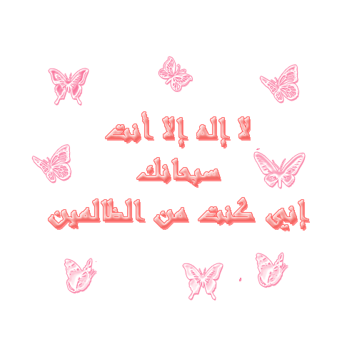
2- A true life story written by the author himself about his own life. (…………….)
3- People in a novel or a play. (…………………)

Lesson | Unit | Date
2 | 1

 Complete the following :
 Ali and Sa'ad are talking about English literature.
Ali : What did Shakespeare do ?
Sa'ad : …………………………………
Ali : Did he write novels ?
Sa'ad : …………………………………
Ali : ……………………………………?
Sa'ad : No, he was not American. He was English .
Ali : Were his books biographies ?
Sa'ad : ……………………………………

Homework

 Huda and Nouf are talking about English literature.
Huda: Do you like reading plays and novels in English?
Nouf: Yes, I do.
Huda: So, name one author who wrote novels in 19th century?
Nouf: ………………………………….
Huda: Did he ……………………….?
Nouf: No, he wrote novels.
Huda: What is ………………..?
Nouf: It is a long story.

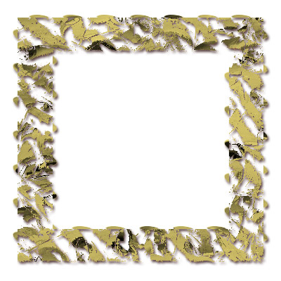

رب أعني ولا تعن عليّ ، وانصرني ولا تنصر عليّ
وامكر لي ولا تمكر عليّ وأهدني ويسر الهدي إليّ ،
وانصرني على من بغى عليّ
اللهم ارزقني حُبك وحُب من ينفعني حُبّهُ عندك
اللهم ما رزقتني مما أُحبُ فاجعله قوة لي فيما تحب
اللهم ما زويت عني مما أُحب فاجعله فراغاً لي فيما تحب -


حقيقٌ بالتواضعِ من يَموتُ * ويكفي المرءَ من دُنْياهُ قوتُ
Lesson | Unit | Date
3 | 1

The Past Tense / The Present Perfect
 Write the correct form of the verb:
1- He ( live)……………… in the nineteenth century.
2- She has ( teach )…………………… English for five years.
3- They ( leave )…………….... Egypt three years ago.
4- We have ( work )……………… hard.
Forming Questions (Past Tense)
 Make questions using the words in brackets ::
1- She listened carefully to the teacher. ( “How” )
…………………………………………………
2- Sana went to the library to read. (“Why”)
…………………………………………………
3- They felt better by night. (“When”)
…………………………………………………
Passive ( Past Tense )
 Change the following into passive:
1- My sister ate the cake.
……………………………………………
2- He found good books in the library.
……………………………………………
3- Farmers grew vegetables.
………………………………………………
4- Mona made the beds, didn’t she?
……………………………………………
5- Did Ali write those novels ?
……………………………………………
If-clause ( Past Tense )
 Correct the verb:
1- If I were a doctor, I ( treat )………………………….. poor patients.
. 2- If I ( have) ………………… enough money, I would travel abroad
3- She (pass) exams if she studied hard .
4- If she (be) rich , she would buy a new car .
 Choose the correct word from those in brackets:
1- If I (am - is - were ) you , I would study harder .
2- If I ( were-am-is ) an explorer, I would travel to remote places .
3- If I ( had- have- has ) enough money , I would travel abroad.

Lesson | Unit | Date
4 | 1

 Give one word for the following :
1- Things you hope will happen or you will get. (……………….…….)
2- The time after childhood is (…………….)
3- A lot of money. (…………………)
 Fill in the spaces:
flat – allowance – childhood – strict – attempted – convict – judge

1- She saved some of her ………………….. to buy a new computer.
2- He lives in a …………….. in that white house.
3- She is a very ………………. mother, she doesn’t allow her daughters to visit
their friends.
4- Nora ……………….. many times to write novels but she failed.
5- In my ……………………, I was fond of playing with toys.
6- The police recaptured the …………………..

Homework:

1- Where did the story take place ?
…………………………………………………………………………
2- Match the following:
a – begin ( ) rich
b –receive ( ) start
c –wealthy ( ) get

3- Write the correct form of the words in brackets.
1- His …………….. makes him friendly to all people. ( kind )
2- Naser Al-qasabi is a famous …………….. . ( act )
3- The story in that book is not true. It is ……………… ( fiction )
4- The little boy was ………………. He had nobody to play with. ( lone )
5- This ……………. consists of 50 lines. ( poetry )

Lesson | Unit | Date
5 | 1

Exercises

( A ) Match words in (A) with the right definition in (B) :
( A ) ( B )
1- prisoner ( ) having no parents
2- poet ( ) take care of
3- career ( ) without friends
4- allowance ( ) a person kept in prison as a punishment
5- orphan ( ) a person who writes poems.
6- bring up ( ) job, a person’s working life
7- lonely ( ) some money given regularly to a person

( B ) Put these words instead of the underlined ones :
firm - poet - bring up – helpful
1- We take care of orphans in special homes .
2- My father works in a big company .
3- You should be kind to animals .
4- Shakespeare was a famous writer of poems .
( C ) Use the correct forms of the words in brackets to fill in the spaces .
( insure ) 1- You must have car ……… before driving on the road .
(alone) 2- The little boy was ……………..
( kind ) 3- I’ll never forget my father’s …………
( expect ) 4- Dickens wrote a story called “ Great …………”.
( D ) Fill in the spaces using the correct words :
flat - king - fortune - childhood – sentenced
1- He is very wealthy. He made his ………… in the fast food business .
2- We know a lot about him as a man but little about his …………
3- On holiday, some families stay in a hotel. Others rent a ……….
4- The convict was ………… to a year in prison .
( E ) Fill in the spaces:
part owner –career – stage – insurance –kind –poem –lonely

1- You have to pay to the hospital if you do not have health …………………….
2- Ahmad is a ……….. …………….. of this house.
3- She is very ………………. to her children.
4- A person feels ……………….. without friends.
5- A piece of writing that often has lines and repeated sounds is called a …………
6- She started her ………………….. as a science teacher.

Lesson | Unit | Date
6 | 1

Past Perfect
 Change the following into passive:
1- They had killed the animal.
………………………………………………………………………………………….
2- She had bought a new dress.
………………………………………………………………………………………….
After / Before
 Choose the correct word from those in brackets:
1- Before they went to bed , they ( had –had been –have ) heard the news.
2- Before he died, he ( sentenced –had been sentenced –had sentenced ) to death by the judge.
3- After the government ( take –had taken –had been taken ) the convict’s money , Pip had to find a job.
4- After I ( had done – done – did ) the homework, I slept.

Reported Speech

Reporting Statements | Reporting Questions
S + said ( that ) …….  e.g.  She said, “ Ahmad lived in Jeddah “  ⇨ She said ( that ) Ahmad had lived in Jeddah.  e.g.  He said, “ I have done my homework “  ⇨ He said ( that ) he had done his homework. | Yes / No Questions:  S + asked if + QW + S + V  e.g. She asked, “ Did Dickens write novels ?”  ⇨ She asked if Dickens had written novels.  e.g. She asked, “ Have you been in school ?  ⇨ She asked if I had been in school.

 Report the following sentences:
1- She said, “ I have lost my pen. “
………………………………………………………………………………………….

2- He asked, “ Did the teacher explain the lesson ? “
………………………………………………………………………………………….
3- Huda said,” I have not done my homework. “
عندما تنتقد أحداً .. فبعين النحل تعود أن تبصر ..
ولا تنظر للناس بعين ذباب .. فتقع على ما هو مستقذر!
…………………………………………….
4- Khaled asked, “ What did you do? “
…………………………………………….
5- Ahmad : “ I have studied abroad.”
……………………………………….

Lesson | Unit | Date
7 | 1

Writing

 Do as shown between brackets:
✰ ( Write the plural of these nouns )
1- life ……………. / 2- party ………………. / 3- foot …………………
4- woman ………… / 5- box ………………. / 6- planet ………………
7- knife ………… / 8- boy ………………. / 9- tooth ………………
10- man ………… / 11- star ………………. / 12- sheep ………………
13- bird …………... / 14- watch ……………… / 15- fish ………………..
✰ ( Add “ed” to these verbs )
1- finish ……………. / 2- try ………………. / 3- stop …………………
4- pray ………… ... / 5- dry ………………./ 6- talk … ………………
✰ ( Add “ing” to these verbs )
1- swim ……………. / 2- use ………………. / 3- sit …………………
4- wait ………… ... / 5- flow ……………… / 6- cut ... ………………
7- run ……….…… / 8- rise ……………….
¶ ( Add “s” to these verbs )
1- fly ……………. / 2- watch ………………. / 3- stop …………………
4- pray ………… .../ 5- dry ……..…………. / 6- eat ……………………
¶ ( Re-write the following sentences after correcting the underlined mistakes )
1- my brother worked in jeddah .
………………………………………………………………………………………….
2- macbeth was Written by william shakespeare .
………………………………………………………………………………………….
3- asma wanted to learn german .
………………………………………………………………………………………….
4- calligraphy is Propably the most Important form of art for muslims .
………………………………………………………………………………………….
¶ ( Punctuate the sentence using a capital letter and a full stop )
1- In june, Mrs Omar is expecting a baby.

الـــــــلهم لك الحمد كما ينبغي لجلال وجـــــهك وعــظيم سلطانك
اللهم افتح لي أبواب رحمتك و افتح لى أبواب مغفرتك.. آمين
………………………………………………………………………………………….

Lesson | Unit | Date
8 | 1

Writing

 Write 2 paragraphs using the information in the following table:

English Literature

Meaning | - the art of writing.  - novels, poems, plays, biographies and autobiographies
a novel : a long story-
- a play : a story acted on the stage
a biography and autobiography / true and real life stories-
Famous writers | 1- William Shakespeare  - lived in the 16th century  - plays and poems
2 - Charles Dickens
- lived in the 19th century
- novels ; “Great Expectations”

…………………………………………….
………………………………………………………………………………………….
………………………………………………………………………………………….
………………………………………………………………………………………….
………………………………………………………………………………………….
………………………………………………………………………………………….
………………………………………………………………………………………….
………………………………………………………………………………………….
………………………………………………………………………………………….
………………………………………………………………………………………….
………………………………………………………………………………………….
………………………………………………………………………………………….

………………………………………………………………………………………….
………………………………………………………………………………………….
………………………………………………………………………………………….

