المملكة العربية السعودية  المادة /انجليزي

وزارة التربية والتعليم الزمن/ ساعة ونصف

الإدارة العامة للتربية والتعليم ب.............. الصف /ثاني متوسط

مدرسة ................................ الاختبار النهائي للفصل الدراسي الأول لعام : 1426 هـ

اسم الطالب:
السؤال | 1 | 2 | 3 | 4 | 5 | 6 | الشفوي | المجموع
الدرجة
المصحح
المراجع

1- Read the following paragraph , then answer the questions:-
The Last Prophet (PBUH)
Prophet Mohammad ( peace be upon him) was born in Makkah in 571 AD. He was an orphan. His father, Abdullah, died before he was born. His mother, Amena, died when he was a child of six. He lived with his grandfather, Abdul Muttaleb, and then with his loving uncle, Abu - Taleb.
1- When was Prophet Mohammad (PBUH) born?
-…………………………………………………………….
2- How old was he when his mother died?
-……………………………………………………………….
3- CHOOSE:-
- An orphan is a child who doesn't have……………………………
a. brother b. uncle c. father

2- A- Do as shown between brackets:-
a. She goes to Al-Huda Intermediate School.
-Which………………………………………………………… ? ( Ask )
b. I like swimming.
-……………………………………………………. ( Change to negative )
B- Choose the right words:-
1- …………you go to Taif yesterday? ( Do / Did / Does )
2- They ………… in Jeddah last week. ( was / are / were )
3- That is Layla and………… sister Hind. ( his / her / their )
4- I ……….. pray Fajr on time. ( always / not / has )
5- Where did they…………. lunch? ( has / have / had )
6- ………… you traveling now? ( Is / Am / Are )
3-Match the words to the pictures:-
{airport / beach / shepherd / bow / sleeping / the world / sewing / study / secretary / painting }
 |  | 

4- Answer these questions:-
1- Where were you born?
-………………………………………………..
2- What is your favourite hobby?
-………………………………………………….
3- How often do you meet friends?
-………………………………………………….
4- What is your father's job?
-……………………………………………………….
5- Put the missing letters:-
  s ell | 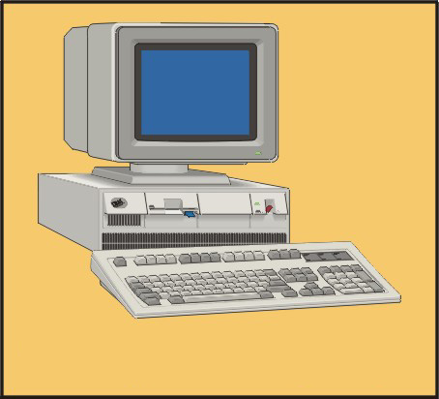  comp ter | 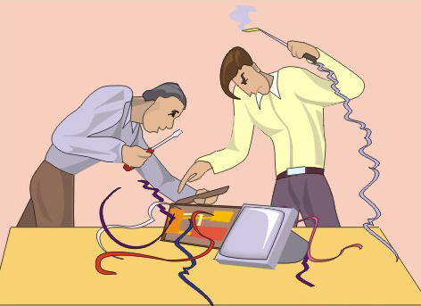  wor ing |   flo rs
6- Copy the following sentence four times:
He likes playing football.
___________________________________________________________________________________
___________________________________________________________________________________
___________________________________________________________________________________
___________________________________________________________________________________
___________________________________________________________________________________

Good luck!

